Earth and Space Science - Geology

Student Name: SOLUTIONS

The following task consists of two parts. You will complete this task across two periods.

Section | Activity | Marks available
A | Looks at the theory behind the rock cycle. Answer the questions in the spaces provided. | /30
B | Is a practical assessment. Follow the instructions and write your answers in the space provided. | /24
 | TOTAL MARKS | /54

Section A: Rock Cycle Theory _________ /30 Marks

The Rock Cycle can be displayed as a diagram that shows the slow, continuous process of rocks changing from one type to another.
A trip through the rock cycle takes millions of years.

Consider the diagram below.
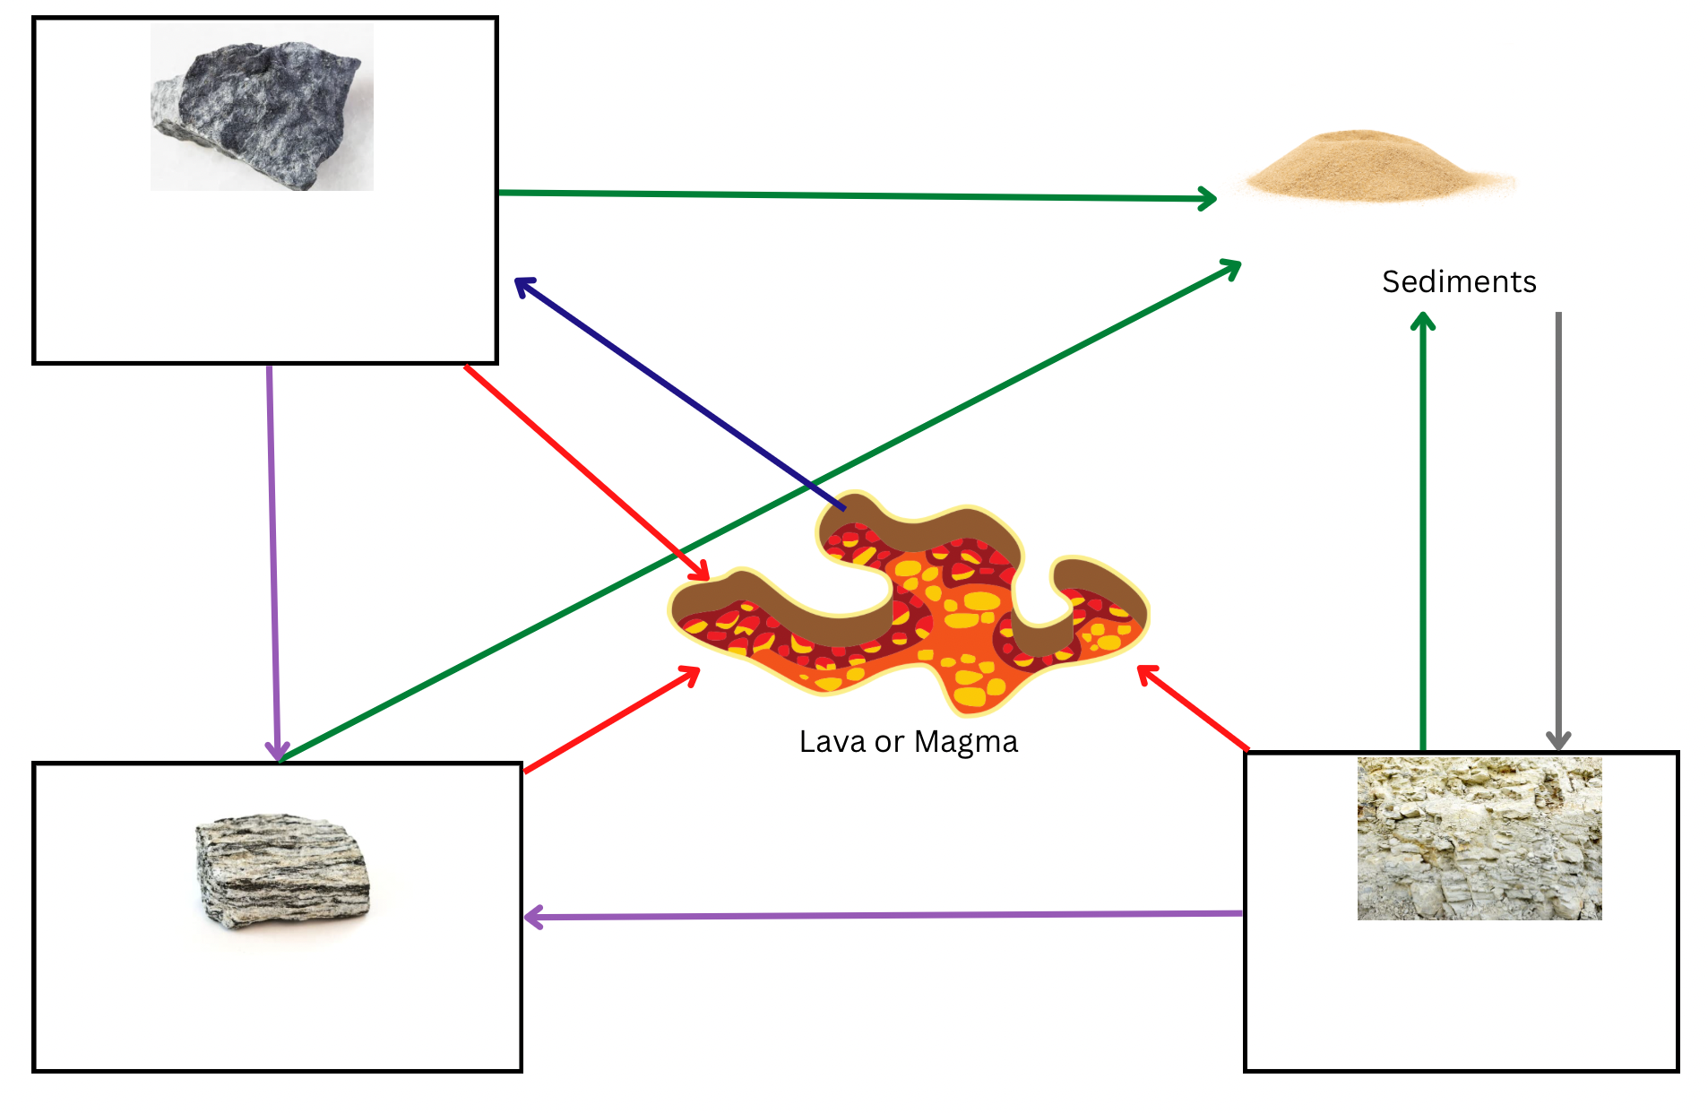
- Complete the rock cycle diagram below.
SEDIMENTARY ROCK

METAMORPHIC ROCK

IGNEOUS ROCK
- In each of the boxes, enter the type of rock. (3m)

- Complete the table by labelling each of the processes indicated by the arrow in the diagram above. (5m)

Coloured arrow | Name of process
 | Pressure
 | Heating or Melting
 | Weathering and Erosion
 | Cooling or Condensing
 | Compacting and Cementation

- Label the following rocks with either metamorphic, sedimentary or igneous. (5m)
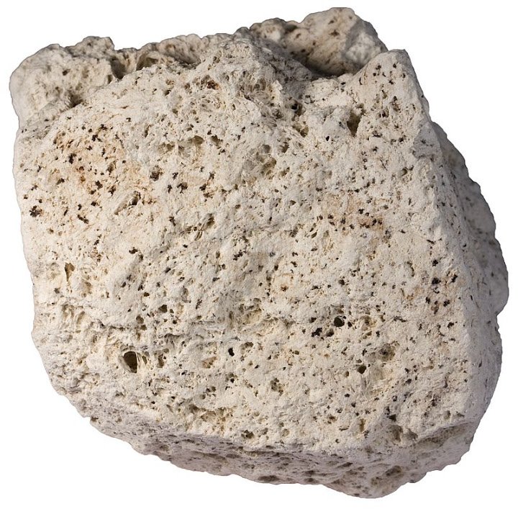
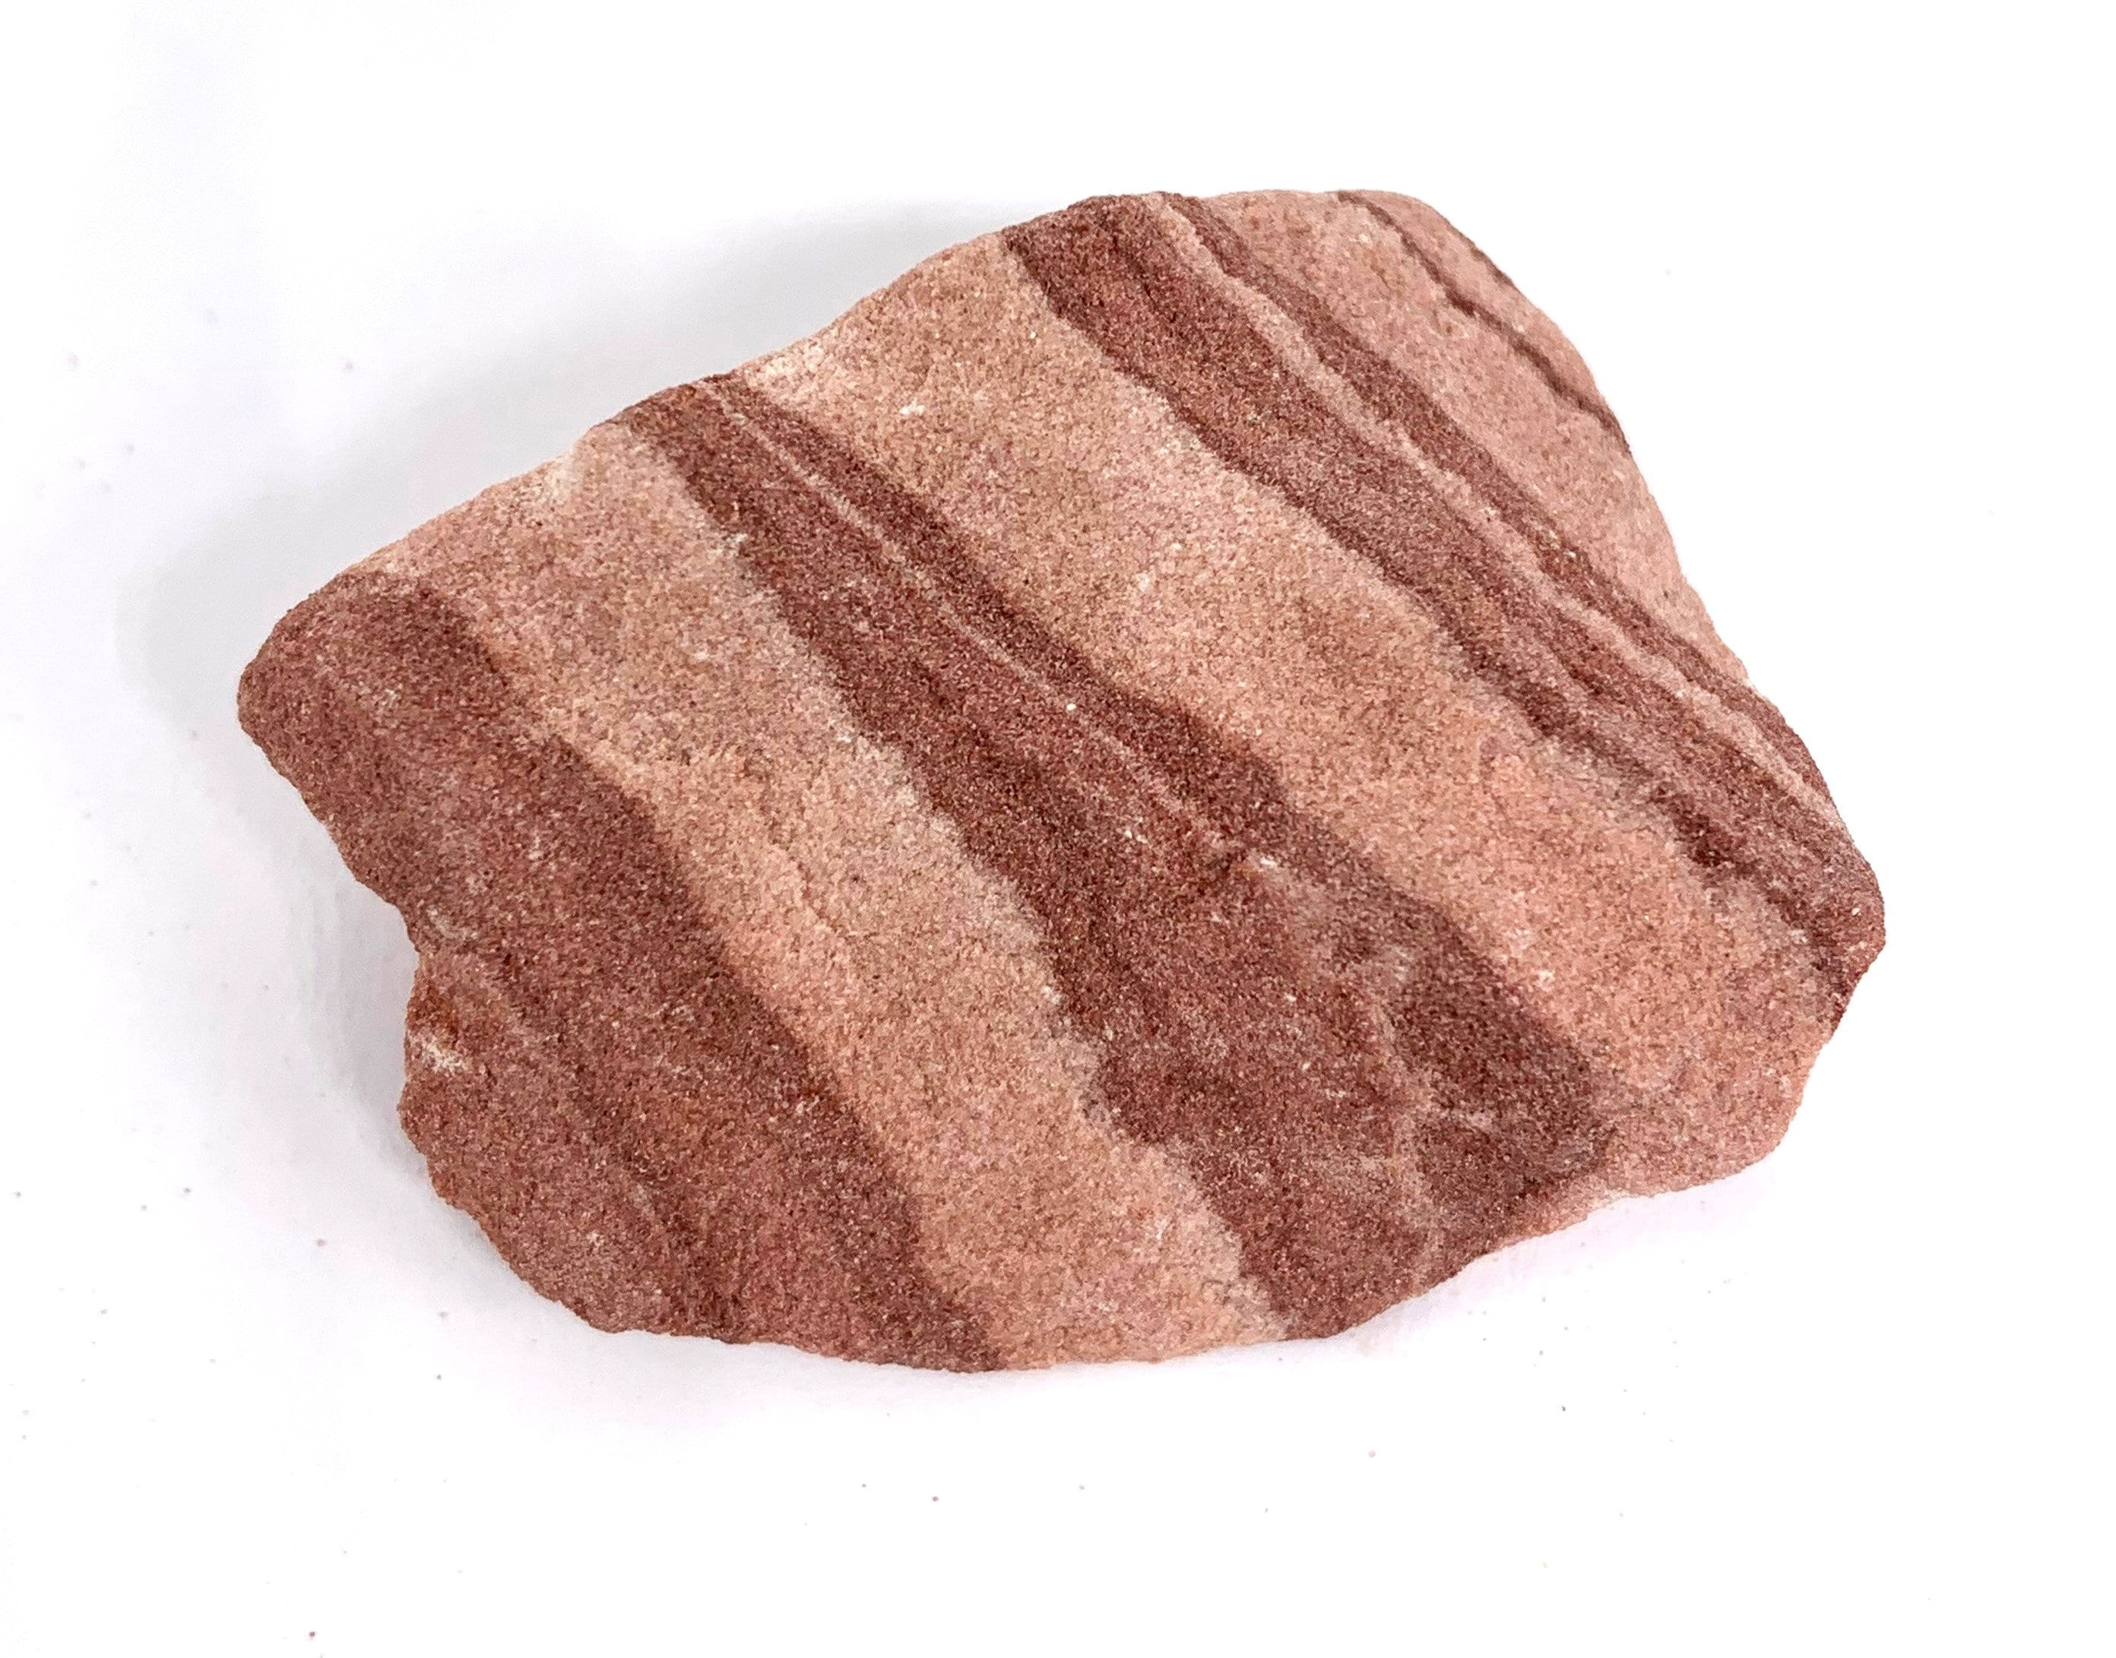
SEDIMENTARY
SEDIMENTARY
IGNEOUS

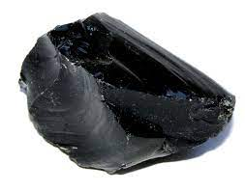
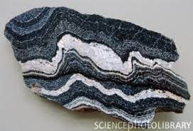

METAMORPHIC
IGNEOUS
____________________ _____________________

- What is the difference between lava and magma? (1 m)

Magma is under the surface of the Earth, lava is on the surface of the earth.

- Use the following pictures to answer questions a and b.
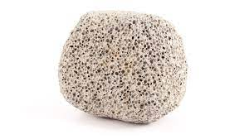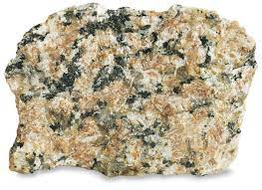
B
A

- Which rock is intrusive? B (1m)
____________________________________________________________
- Which rock cools quickly? A (1m)
____________________________________________________________
- Explain how you made your decision in b). (1m)
Reasonable explanation

- Distinguish (tell me the difference) between weathering and erosion. (2m)
Weathering breaks rocks down to small pieces, erosion carries them away.
Weathering is the process by which rocks are broken down into smaller pieces, whereas erosion is when larger chunks of rocks break loose and move to a different location.

- Distinguish (tell me the difference) between rocks and minerals. (2m)
Rocks are made of minerals (1). Minerals are chemicals of a certain composition (1)

- An archaeologist was on a dig in Australia. She came across a number of fossils as shown below.

- Which fossil is the oldest? D (1m)
________________________________________________________________

- Explain why you gave your answer in part a). (1m)

it is at the bottom, with other layers on top

- What rock type would she have been digging in? Why? (2m)

sedimentary (1) because it has layers (1) or organic material (1)

- You have been asked to select a building material for a new construction and have narrowed the choice down to three minerals. Your final decision will be based on which of the minerals is the hardest.
Describe the steps you would use to determine the hardest mineral, without looking them up on the Moh’s scale. (5m)

Students’ answers will vary. Award 1 mark for each logical step for a maximum of 5 marks.
- Identify scratch test
- Logical sequence to their description
- Use mineral A to scratch minerals B and C and record the results.
- Use mineral B to scratch A and C and record the results.
- Use mineral C to scratch A and B and record the results.
- The hardest mineral will be able to scratch the other two without being scratched by either.

Section B: Rock Cycle Practical _________ / 24 Marks

Student Name: ____________________________

Materials:
- 1 Cube of sugar
- 10 cm² Foil
- 10 cm² White paper
- Candle
- Hand Lens
- Wooden test tube peg

Step 1: Examine the sugar cube with a hand lens

Observations - Describe what you see by completing the boxes below. |  | ___ / 3 Marks  ½ mark each
Grain size | approx. 1mm or less
Grain shape | Cubish
How close the grains are? | Very close together
Are the grains cemented together? | Yes
Overall shape of the sample | Cube
State of Matter (Solid, liquid, gas) | S

Conclusion - Relate your observations to the Rock Cycle | ___ / 3 Marks
What rock type does this represent?  Sedimentary  Explain why  Individual grains (rocks) (1) cemented together (1) | ___ / 1 Mark  ___ / 2 Marks
Step 2: Place sugar cube on white paper square and use the back of the tongs to crush part of the cube into a powder.

Observations - Describe what you see by completing the boxes below. |  | ___ / 3 Marks  ½ mark each
Grain size | Less than 1mm
Grain shape | irregular
How close the grains are? | Far apart, spread out
Are the grains cemented together? | no
Overall shape of the sample | irregular
State of Matter (s,l,g) | S

Step 3: Fold the edges of the foil over to make a small bowl. Pour the crushed sugar into the foil bowl.

Conclusion - Relate your observations to the Rock Cycle | ___ / 2 Marks
What process in the Rock Cycle does the movement from place to place, of the crushed sugar represent?  Erosion  Explain why and how:  Moving the particles from one place to another | ___ / 1 Mark  ___ / 1 Mark

Step 4: Use the metal tongs to hold the bowl over the candle flame. Write down what your observations are as the sugar begins to melt.

Observation - Relate your observations to the Rock Cycle | ___ / 3 Marks
What process in the Rock Cycle does this replicate?  Melting  Explain how this comes about in the Rock Cycle:  Rock is forced beneath the crust into the mantle (1) where temperatures are high enough to melt rock (1) | ___ / 1 Mark  ___ / 2 Marks

Step 5: Set the foil bowl aside and let the sugar cool and harden. Write down what your observations are as the liquid begins to cool.

Observations - Describe what you see by completing the boxes below. |  | ___ / 1 Mark  ½ mark each
Grain present? | No
Overall shape of the sample | Irregular, shape of the container

Observation - Relate your observations to the Rock Cycle | ___ / 3 Marks
What process in the Rock Cycle does this replicate?  Cooling of magma  Explain how this comes about in the Rock Cycle:  When magma is forced to the surface of the Earth and becomes lava it cools, becoming hard  Igneous rock is formed | ___ / 1 Mark  ___ / 2 Marks

Step 6: Break the hardened sugar into pieces by crumpling the cooled foil a little. Write down what your observations are as the sugar begins to break up.

Observation - Relate your observations to the Rock Cycle | ___ / 6 Marks
What process in the Rock Cycle does this represent?  Weathering  What is produced from this process in the Rock Cycle?  Sediments  What do you notice about what you did in step 2, and what you did in step 6?  Same action, both produce sediments  What does this say about the rock cycle and the paths a rock can take?  The rock cycle is a continuous cycle  Rocks can move through different paths in the cycle | ___ / 1 Mark  ___ / 1 Mark  ___ / 2 Marks  ___ / 2 Marks

